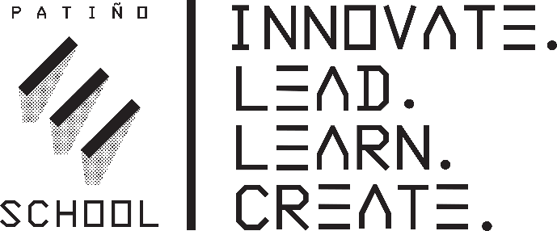

PRINCIPAL
Blair Sagardia
VICE PRINCIPAL
Leah Herrera

COUNSELOR
Oscar Barragan

Phone: 559-248-7360
Fax: 559-248-7361

July 22, 2022

Dear Students, Parents, and Guardians,

As the principal of Patiño School of Entrepreneurship, it is my pleasure to welcome everyone back for another great year of entrepreneurial endeavors. We are so excited to have students back in classrooms filling them with innovation, creativity, and entrepreneurial spirit.

Our teachers and staff have been working hard to create experiences that will prepare students for the exciting opportunities they will have to showcase their learning throughout the year. We also strongly believe that education is a partnership between home and school and we look forward to your involvement in ensuring the success of your children.

As you prepare for the beginning of the school year, please keep in mind:
- Late registration takes place August 2nd and August 9th, 2022, from 4:00pm-7:00pm.
- The first day of school is August 15th, 2022.
- Monday – Friday, school runs from 9:00am-3:43pm.
- Buses will pick up/drop off students at each comprehensive high school site in the morning and afternoon. (**Please see the bus schedule included in the packet for more information about locations/times.)
- All students should be picked up no later than 5:00pm Monday-Thursday and 4:15pm on Fridays. Our office closes at 5:00pm Monday-Thursday. Friday, our office closes at 4:30pm.
- Breakfast will be served until 9:00am Monday-Friday.
- The PINK stapled forms in the start-of-school paperwork along with emergency cards must be completed/signed and returned:
(**If you are joining us from out of district, you will also need to bring immunization records, transcripts, and current PGE, water bill or rental agreement.)
  - 9th grade students: return packets August 9th from 8:30am-11:30am.
  - 10th grade students: return packets August 10th from 8:30am-11:30am.
  - 11th & 12th grade students: return packets August 11th from 8:30am-11:30am.
- All students will receive their class schedules the first week of school.
- Back to School Night will be held on September 9th, 2022, from 5:15pm-6:15pm.

I am truly honored to have the opportunity to continue to serve as principal of Patiño School of Entrepreneurship. It is such a privilege to be a part of a team where community, parents, teachers, and students strive to build both positive relationships and exciting intellectual learning experiences that support academic and social/emotional growth.

Please feel free to contact me at 559.248.7360 or at blair.eliason@fresnounified.org.

Once again, welcome back and I can’t wait to see all our students will accomplish this year!

Sincerely,

Blair Eliason Sagardia
Principal

